**CHAPTER 1**

**INTRODUCTION**

**Web technology** refers to the means by which computers communicate with each other using markup languages and multimedia packages. It gives us a way to interact with hosted information, like websites. **Web technology** involves the use of hypertext markup language (HTML) and cascading style sheets (CSS). In order to make websites look and function a certain way, web developers utilize different languages. The three core languages that make up the World Wide Web are HTML5, CSS, and JavaScript.

In the IT world, the internet is an essential platform, whether it’s for developing or for consumer use. When developing a website, typically three main languages come into play. These languages are JavaScript, CSS, and HTML. HTML is the backbone of most webpages. Essentially, it is used to create the structure of how a specific website would look like, from the headings, to the paragraphs, the body, links, and even images. **Markup languages** are the languages in which the web is written. The most common markup language used is HTML, which uses tags to annotate text so that a computer can then manipulate the text. Most markup languages are human readable, and use annotations that are distinguishable from the annotated text. There are many different kinds of markups and languages, but all are consistent in the way in which they annotate documents.

**Hypertext** is defined as the arrangement of information inside a database that allows the user to receive information and to navigate from one document to another by clicking on highlighted words or pictures inside the primary document. Hypertext is the base of the World Wide Web, because it enables user to click on other links to get more information. Hypertext is a term used for all links, whether it appears as texts or other graphical part.

**HTML** is the conventional markup language used to create and edit web pages and web applications. HTML is used for creating the basic structure of a website. HTML consists of different elements preceded by an opening tag, <tag>, and a closing tag, </tag>. The content between the tags, <html> and </html>, is the content of the webpage. The content between the tags, <head> and </head>, is the title of the webpage. This text is displayed between the <title> and </title> tags. The content between the tags, <body> and </body>, is the main content of the webpage. The content can include links, paragraphs, headings, and various other elements.

**CSS** is a style sheet language standard set by W3C (World Wide Web Consortium) used to create and edit the visual presentation of web pages. CSS allows web developers to isolate a web page's content and visual styles into separate documents and gives better page layout control. An external CSS sheet is generally linked to HTML and XHTML, it also can be linked to XML, SVG, and XUL. HTML and JavaScript, with CSS, is a vital part of technology used by the majority of interfaces for websites. This is also used in interfaces for mobile devices making the websites more engaging.

CSS can be incorporated with HTML in 3 different ways; Inline, Internal, and External.

1. **Inline styles** add style to a single element on the page by placing 'style' after the element you wish to be styled.

*Ex: h2 style = "color: blue"*

1. **Internal styles** create a style for a single document because the CSS is stored in the head of the HTML document. Internal styles are placed using a *<style>* tag around all style selectors.

*Ex: <style>  
body {background-color: white;}  
/*This is a comment!  
'Body' is the selector,  
'background-color' is the declaration*/  
h2 {color: blue;}  
</style>*

1. **External style sheets** exist in separate documents from HTML documents, allowing for better organization of style and structure. An external style sheet can be linked to all HTML documents making up a web site, allowing a web developer to style the entire site (all pages) using one document.

**JavaScript** is a scripting language that is used along with HTML and CSS as the three core components of the World Wide Web. JavaScript has first-class functions and is used in most websites. JavaScript does not have any I/O which means that it has to be embedded in the host environment. JavaScript is also used in PDF documents, game development, and desktop and mobile applications. JavaScript is most commonly used to make DHTML by adding client-side behavior to HTML pages.

**PHP** stands for Hypertext Preprocessor (no, the acronym doesn't follow the name). It is an **open source**, **server**-side, scripting language used for the development of web applications. By scripting language, we mean a program that is script-based (lines of code) written for the automation of tasks.

**1.1 Overview of the Mini Project:**

* People face problems to buy magazines weekly from the stores.
* The magazines are updated only on a weekly basis.
* The printed magazines are waste once they are outdated.
* Printed magazines don’t provide a platform to interact.
* Printed magazines are limited to certain number of pages.
* Digital magazines are available online anywhere, anytime.
* Digital magazines can be updated anytime whenever there is latest news
* The Digital magazines are just updated and there is no wastage.
* Digital magazines provide a platform to interact.
* Digital magazines can be of any number of pages.
  1. **Aim of the Mini Project:**
* To develop an electronic magazine for the Tech Freaks.
* Here we provide the users with the latest updates on:
  + Smart Phones
  + Smart Televisions
  + Smart Watches
  + Laptops
  + Latest gadgets
* Users may buy the desired product through the link provided.

**CHAPTER 2**

**REQUIREMENT SPECIFICATION**

**2.1 Functional Requirements:**

Functional Requirements defines the internal working of the software, i.e., the calculations, technical details, data manipulation and processing and other specific functionality that show how the cases are to be satisfied and how they are supported by non-functional requirements, which impose constraints on the design or the implementation.

The following are the Functional requirements:

1. The ability to perform correct operation when the corresponding keys are pressed.

2. The ability to display the correct information as stored in database.

3. When the corresponding key is selected, the corresponding operation should be performed.

4. Ability to register athletes on the procurement of correct information.

**2.2 Non-Functional Requirements:**

Nonfunctional requirements are requirements which specify criteria that can be used to judge the operation of the system, rather than specific behaviors. This should be contrasted with functional requirements that specify specific behavior or functions. Typical nonfunctional requirements are reliability and scalability. Nonfunctional requirements are “constraints”, “quality attributes” and “quality of service requirements”.

It has the following attributes:

1.>Reliability

2.>Safety

3.>Security

4.>Availability

5.>Dependability

**2.3 HARDWARE AND SOFTWARE REQUIREMENTS:**

**Hardware Requirements:**

* 128 MB of RAM, 256 MB recommended.
* 110 MB of hard disk space required, 40 MB additional hard disk space required for installation (150 MB total).

**Software Requirements:** The software requirements are as follows: -

**Development Platform :** WINDOWS 10

**Language :** HTML, CSS, JAVASCRIPT, PHP

**Tools :** Web Browser such as Chrome or Firefox

**CHAPTER 3**

**DESIGN**

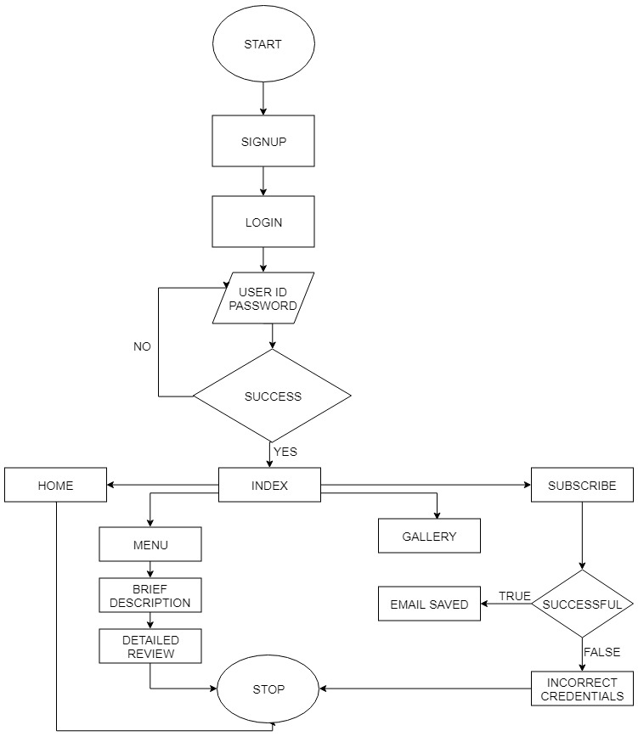

Fig 3.1 Flowchart: DIGITAL MAGAZINE

FLOW OF DESIGN:

* Login page
* Index page
  + Smart Phones
  + Smart Watches
  + Laptops
  + Televisions
  + Gadgets
  + Home
  + Menu
  + Gallery
  + Subscribe
* **Brief description about products**
  + - Detailed review page
    - Buy now link
* Detailed review page
  + Video link
  + Slide Show
  + Description

Front End: -**HTML** is the conventional markup language used to create and edit web pages and web applications. HTML is used for creating the basic structure of a website. HTML consists of different elements preceded by an opening tag, <tag>, and a closing tag, </tag>. The content between the tags, <html> and </html>, is the content of the webpage. The content between the tags, <head> and </head>, is the title of the webpage. This text is displayed between the <title> and </title> tags. The content between the tags, <body> and </body>, is the main content of the webpage. The content can include links, paragraphs, headings, and various other elements.

**CSS** is a style sheet language standard set by W3C (World Wide Web Consortium) used to create and edit the visual presentation of web pages. CSS allows web developers to isolate a web page's content and visual styles into separate documents and gives better page layout control. An external CSS sheet is generally linked to HTML and XHTML, it also can be linked to XML, SVG, and XUL. HTML and JavaScript, with CSS, is a vital part of technology used by the majority of interfaces for websites. This is also used in interfaces for mobile devices making the websites more engaging.

CSS can be incorporated with HTML in 3 different ways; Inline, Internal, and External.

1. **Inline styles** add style to a single element on the page by placing 'style' after the element you wish to be styled.

*Ex: h2 style = "color: blue"*

1. **Internal styles** create a style for a single document because the CSS is stored in the head of the HTML document. Internal styles are placed using a *<style>* tag around all style selectors.

*Ex: <style>  
body {background-color: white;}  
/*This is a comment!  
'Body' is the selector,  
'background-color' is the declaration*/  
h2 {color: blue;}  
</style>*

1. **External style sheets** exist in separate documents from HTML documents, allowing for better organization of style and structure. An external style sheet can be linked to all HTML documents making up a web site, allowing a web developer to style the entire site (all pages) using one document.

**JavaScript** is a scripting language that is used along with HTML and CSS as the three core components of the World Wide Web. JavaScript has first-class functions and is used in most websites. JavaScript does not have any I/O which means that it has to be embedded in the host environment. JavaScript is also used in PDF documents, game development, and desktop and mobile applications. JavaScript is most commonly used to make DHTML by adding client-side behavior to HTML pages.

**PHP** stands for Hypertext Preprocessor (no, the acronym doesn't follow the name). It is an **open source**, **server**-side, scripting language used for the development of web applications. By scripting language, we mean a program that is script-based (lines of code) written for the automation of tasks.

BACK END- The back end is designed using MySQL which is used to design the databases

MYSQL- **MySQL** ("My S-Q-L", officially, but also called "My Sequel") is (as of July 2013) the world's second most widely used open-source relational database management system (RDBMS). It is named after co-founder Michael Wideners. The SQL phrase stands for Structured Query Language. The MySQL development project has made its source code available under the terms of the GNU General Public License, as well as under a variety of proprietary agreements. MySQL was owned and sponsored by a single for-profit firm, the Swedish company MySQL AB, now owned by Oracle Corporation. MySQL is a popular choice of database for use in web applications, and is a central component of the widely used LAMP open source web application software stack (and other 'AMP' stacks). LAMP is an acronym for "Linux, Apache, MySQL, Perl/PHP/Python." Free-software-open source projects that require a full-featured database management system often use MySQL. For commercial use, several paid editions are available, and offer additional functionality. Applications which use MySQL databases include: TYPO, Joomla, WordPress, Drupal and other software. MySQL is also used in many high-profile, large-scale websites, including Wikipedia, Google (though not for searches), Facebook, Twitter, Flickr, and YouTube.

The server administration runs the local instance, used for import/export. It is an open source relational database management system. It has a cross-platform support and is mainly used where users want to make use of stored procedures, etc. Updatable views, cursors, information schema are some of the other features exhibited by it.

**CHAPTER 4**

**IMPLEMENTATION**

This Mini Project is made up of modules needed to work efficiently and in a destined order. We have done the following implementations based on the problem statement and the work related to the Mini Project.

**1.Entry into the database:**

* The login details are to be entered present already in the database.
* The data has been entered into the database properly.
* Insertions made through the front end were checked in the database.
* The email ids of the viewers are entered in the database for news-letter subscription.

**2.Data Security:**

* Data has been properly validated. For example, an empty field has to be filled first and an incorrect information does not yield the necessary result.
* Incorrect data must not be entered into the detail block. For example, the login details and subscription for news-letters.
* Only the admin has privileges.

**3.The main actions are performed through as follows:**

Module Name:

I. Login: **Objective**: - Allows the privileged users to login and view magazine.

**Input**: - User-id and password.

**Output**: - Successfully logged in.

**Description**: - The privileged users are given to view the magazine.

II. Subscribe: **Objective**: - Allows the viewers to subscribe to news-letters.

**Input**: - Enter the email-Id of the viewers.

**Output**: - Successfully subscribed for news-letters.

**Description**: - The viewers subscribed for the news letters are sent email updates and their email accounts are saved in the database.

III. Highlights: **Objective**: View minimal details of gadgets.

**Description**: - It contains a brief description of the gadgets and its pricing. The viewers if needed can click on the title and view the detailed review.

IV. Detailed review: **Objective**: View in detail description of the gadgets.

**Description**: - It contains a detailed description of the gadgets, along with review videos and pricing.

**CHAPTER 5**

**TESTING**

Testing in general means validation and verification. It shows that the system conforms to its specifications and system meets all expectation of the user. The following test cases proves the Mini Project to be running efficiently without any problems.

|  |  |  |  |  |
| --- | --- | --- | --- | --- |
| **Sl. No** | **Functions with**  **parameters under**  **test** | **Expected Result** | **Actual Result** | **Remarks** |
| 1. | When correct credentials are entered by user. | The user must be able to view Details | The user was able to view details | Pass |
| 2. | When admin logs in. | The registration/deletion should take place | Registration/deletion took place. | Pass |
| 3. | When an unspecified data is pressed. | Neither insertion nor deletion should occur. | None of them occurred. | Pass |
| 4. | When wrong email format is entered. | The viewer must be warned. | Warning didn’t occur. | Fail |
| 5. | User subscribed. | The user must get confirmation mail. | No confirmation mail sent. | Fail |

**Tab 5.1 Testing Table**

**CHAPTER 6**

**SNAPSHOTS**



**Fig6.1: Index**

This page contains a link to all the existing pages from which the user can go to gallery, menu, subscribe and home.

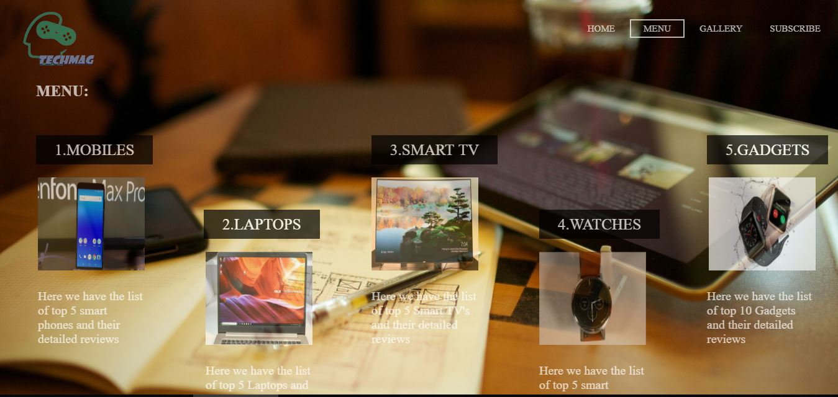

**Fig 6.2: Menu**

The menu page contains link to the categories of gadgets present in the Magazine, to direct directly to the webpage.

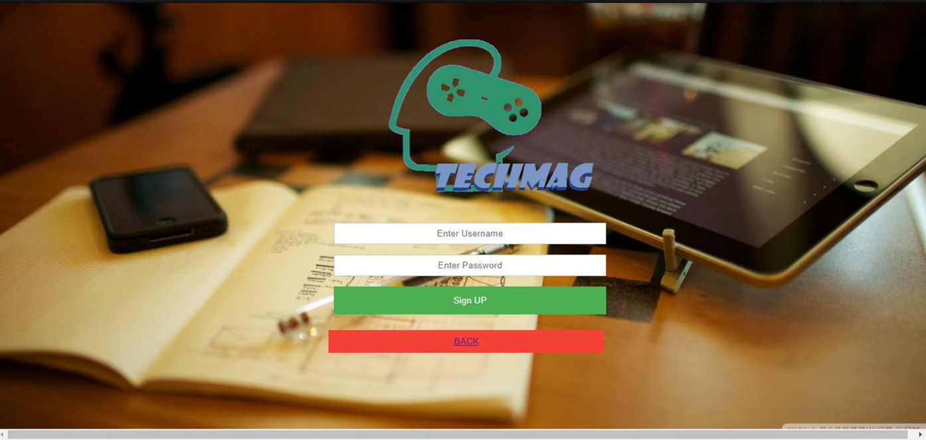

**Fig 6.3: Home Page**

The home page contains boxes for the user credentials to be entered, successful signup will take the user to next page.

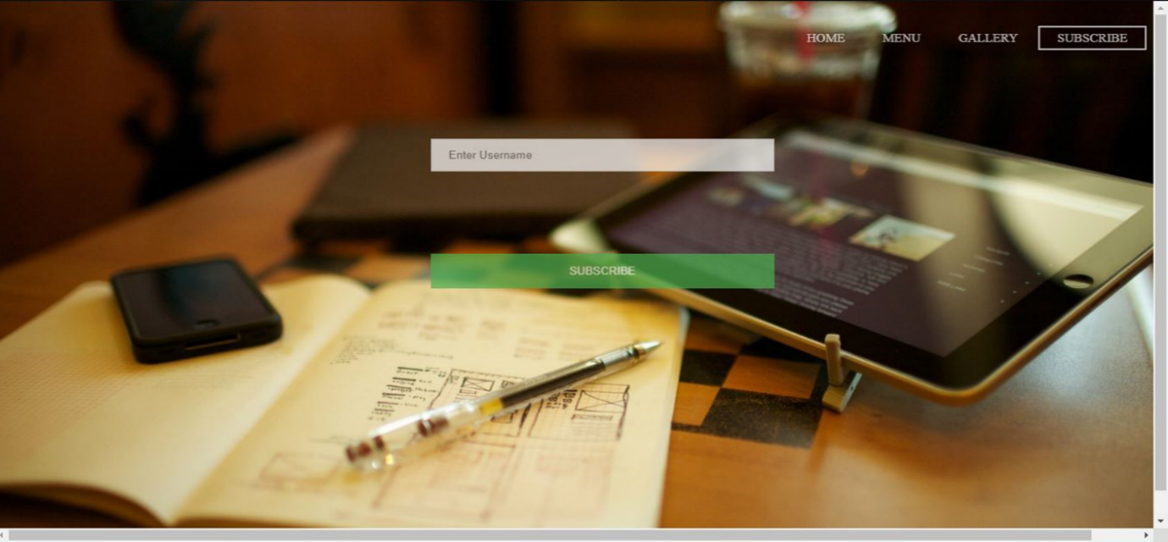

**Fig 6.4: subscribe**

In the subscription page the users can enter the email address and can subscribe to the news-letters and subscribe for future updates.

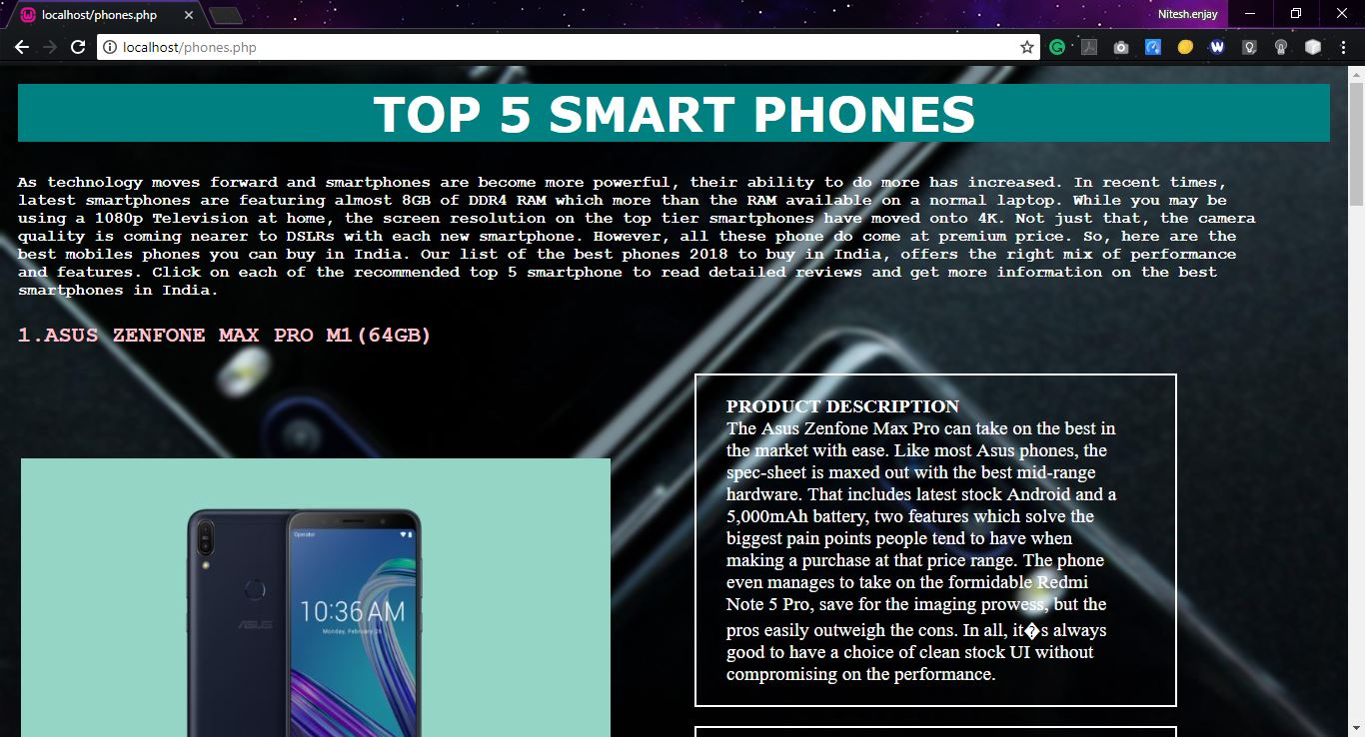

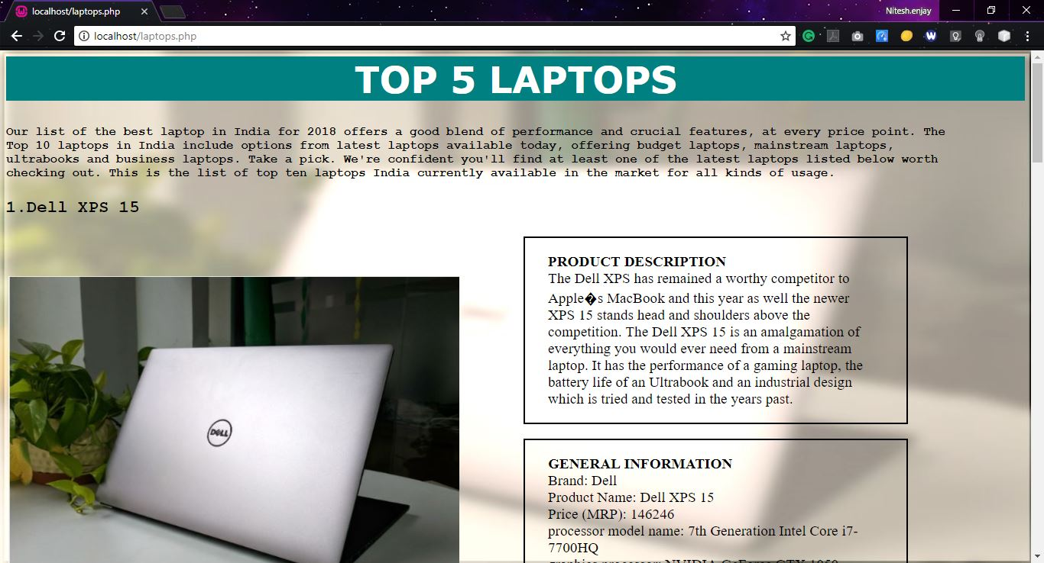

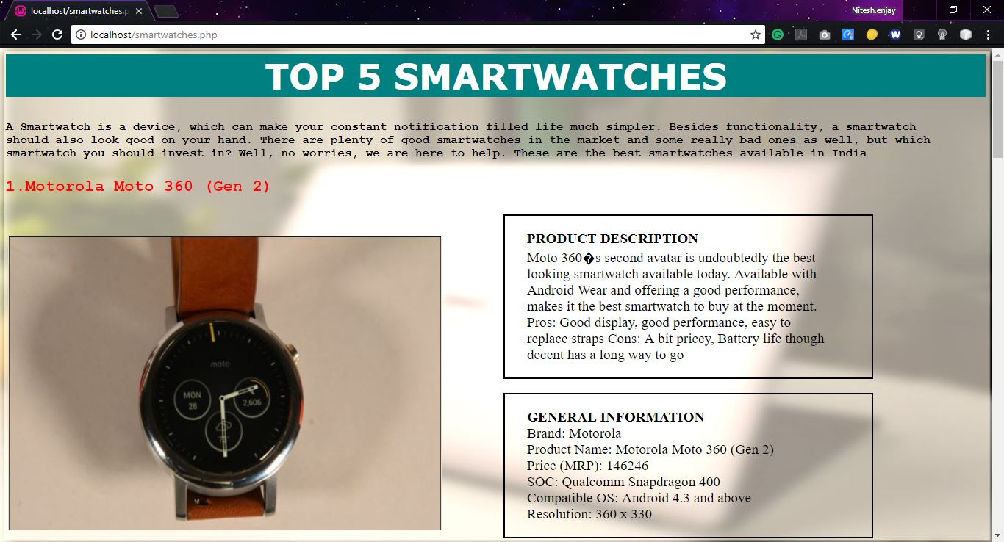

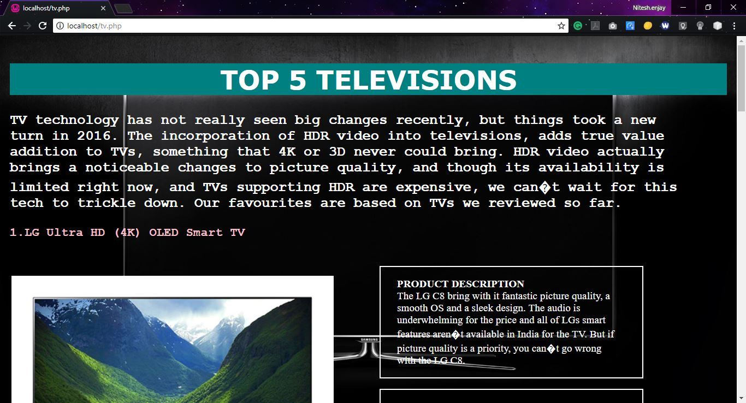

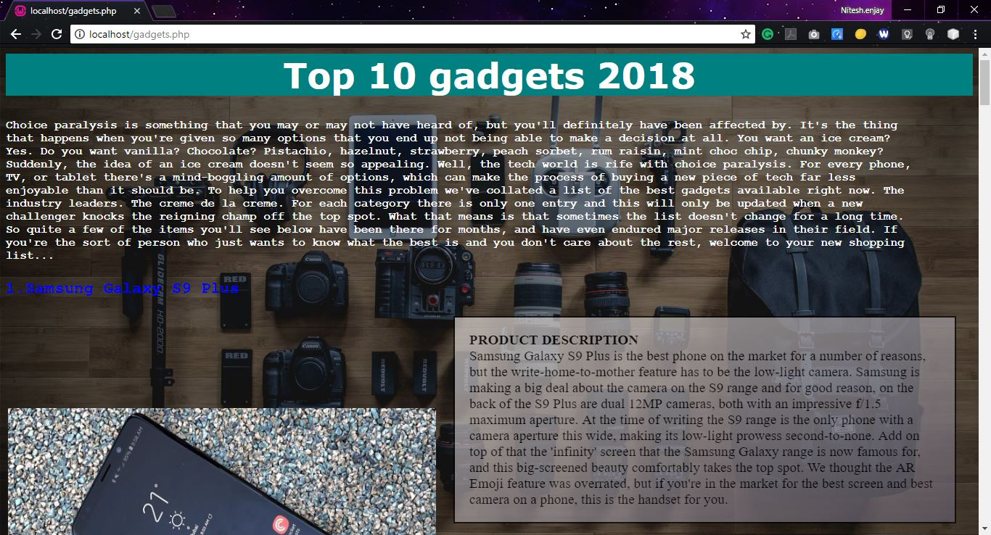

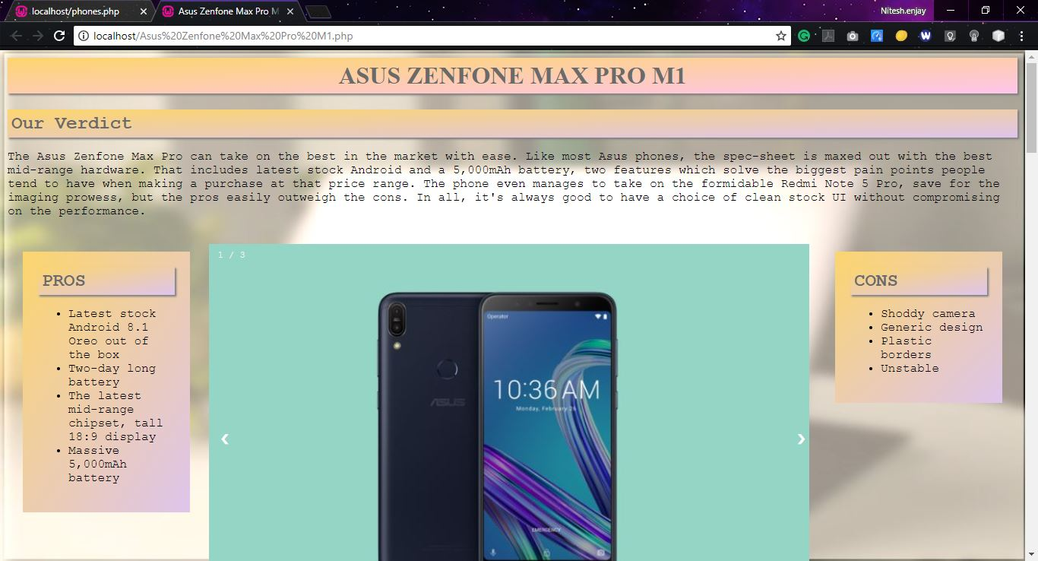

**6.5: Detailed Review Page**

The brief description page contains a brief description of the categorial gadgets, their respective prices, links to the related detailed review pages and links to seller websites for buy now option. This detailed review page consists of the sliding images, review YouTube videos and the pros & cons of the gadget.

**CHAPTER 7**

**CONCLUSION AND FUTURE ENHANCEMENTS**

**CONCLUSION**

The main motive of the Mini Project is to provide users an online platform for reading magazines and provide latest updates on technology. The Digital magazine is designed to provide a user-friendly interface to browse the online magazine with latest news about technology.

By application of programming tools such as HTML, CSS, JavaScript and PHP, we have designed and implemented a basic Digital Magazine. The system is a simple and user friendly. In future, we might implement new functionalities such as a mobile app which the users can use, support to any device like phone, tab, pc and make it more efficient.

**FUTURE ENHANCEMENTS**

Designing of the webpage is needed as to be supported by phone and tablets. Creating a pdf file of the magazine and the email with attached pdf to be sent to the subscribed users. We’ll be developing an android app for TECHMAG magazine where the viewers can access the magazine offline and get it updated when they come online. Making the webpage more efficient in terms of cache utilisation and storage.

**BIBLIOGRAPHY**

* Robin Nixon, **“Learning PHP, MySQL &JavaScript with jQuery, CSS and HTML5”,** 4thEdition, O’Reilly Publications, 2015.
* Luke Welling, Laura Thomson, **“PHP and MySQL Web Development”,** 5th Edition Pearson Education, 2016.
* Nicholas C Zakat, **“Professional JavaScript for Web Developers”,** 3rd Edition, Worx/Wiley India, 2012.
* David Sawyer McFarland, **“JavaScript & jQuery: The Missing Manual”,** 1st Edition, O’Reilly/Shroff Publishers & Distributors Pvt Ltd, 2014.
* <http://www.w3schools.com>